String Positions

Look at this code:
word = input("Enter a word: ")
first = word[0]
preview = word[0:3]
print("Initial:", first, "Preview:", preview)

What do you think this code will do if the user enters 'python'?
Click or tap here to enter text.

Run the code. Compare the result with your prediction:
Click or tap here to enter text.

Let’s investigate! Answer the questions below:
- If you enter python, which character is stored in first?
Click or tap here to enter text.

- If you enter python, which text is stored in preview?
Click or tap here to enter text.

- Why is position 0 the first character rather than position 1?
Click or tap here to enter text.

- For python, what does word[0] return and what does word[0:3] return?
Click or tap here to enter text.

String Positions

Look at this code:
word = input("Enter a word: ")
first = word[0]
preview = word[0:3]
print("Initial:", first, "Preview:", preview)

Use the code above to help you. After completing each challenge below, run your program to test that it works correctly. Save each completed challenge program in a new file.

Programming Challenges

Challenge 1
Change the slice’s stop position so the preview contains four characters instead of three. Try "code" and "python"; both previews should contain four characters.
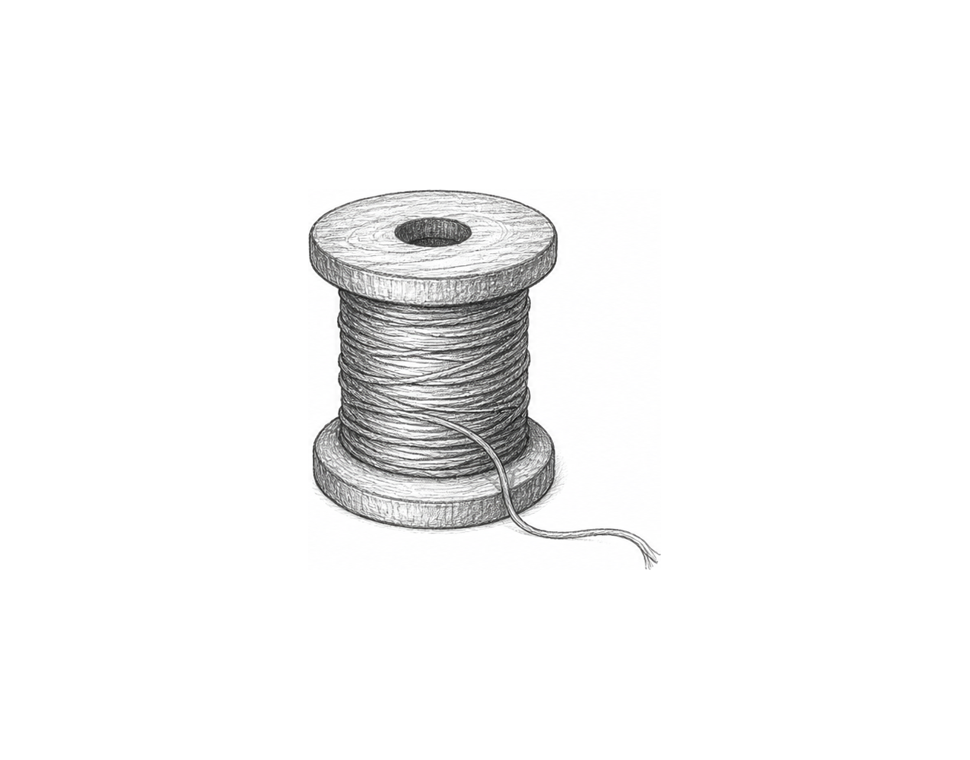

Challenge 2
Create a two-letter badge from two words. Use indexing to display the first character of each; use inputs with different capitalisation to inspect the result.

Challenge 3
Build a reference code for a six-letter word. Use two slices to display its first two characters, then characters five and six. Try "python": the two parts should be "py" and "on".

String Positions

Fix the code!

This code has errors! Look closely at the code to find the problems:

word = input("Enter a word: ")
first = word[5]
preview = word[0:3]
print("Initial:", first, "Preview:", preview)

Rewrite the whole program in the box below with fixes to the errors.
Click or tap here to enter text.

After you are confident that you fixed all the errors, copy the code from the box and run it.

Did it work correctly on your first try? Did you find all the errors?
Click or tap here to enter text.

